## Internet and Mobile Application Design Project

*Darragh Lally – G00220290*

Table of Contents

Internet and Mobile Application Design Project 1

Brief 3

Idea / Research 3

Features 4

Main Page 5

Content Page2 6

Content Page3 6

Content Page4 7

Content Page5 7

## Brief

To provide a design document outlining my goals for the project. To design and develop an application suitable for Android or Windows using C# and XMAL via Visual Studio.

# Idea

I want to develop an application suitable for users that are new to the concept of ‘Wild Camping’. It is intended to give them a brief overview of the information I would have liked to have when first getting into the activity. I want it to be simple and easy to navigate/interact with.

# Research

I have downloaded apps from the play store (related to camping) to see what is available. Below are some examples I found on Google Play Store while researching my design.

**Camping Ireland**

Unfortunately, it crashes before the app opens, so it is impossible for me to comment on its process’s or its value to the user.

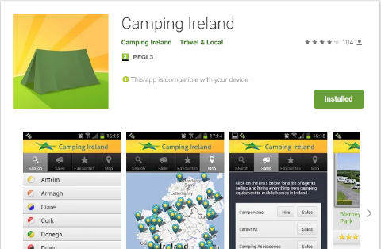 [Camping Ireland](https://play.google.com/store/apps/details?id=ie.fluidink.camping_ireland)

**Camping Checklist**

This app is literally a check list. It has numerous check boxes beside a title that can be checked and unchecked. A check list/notes section in my design is something I may consider adding in the future.

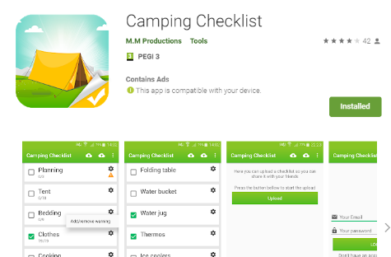 [Camping Checklist](https://play.google.com/store/apps/details?id=com.mmproductions.campingchecklist)

**Offline Survival Manual**

This is a fantastic app full of useful information. I have had it installed on my phone for some time. Unfortunately, it is very clunky and there is a sense of information overload while navigating it.

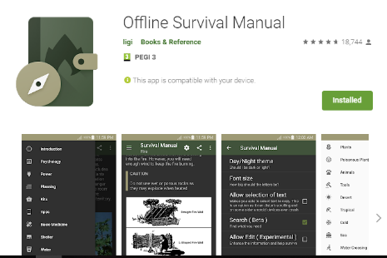 [Offline Survival Manual](https://play.google.com/store/apps/details?id=org.ligi.survivalmanual)

There are various other camping applications available, but they are mostly set for the USA. They provide registered camping sites and hiking trails on a google map type interface. Again, this is of no use to the users I am targeting… because the theory of Wild Camping is to go to the unexplored! My aim is not to make a navigation application, but it is something I will consider adding as an add on in the future.

# Features

* I do not believe a login page is necessary and would take away from the simplistic design I have in mind, so its been omitted. Once the application is open on the user’s device I want it to be ready for use.
* I want something simple and easy to use. I do not want to overload the user with information, so I will only provide details I think are the most important.
* All pages will have a background on which the other information will sit.
* Its hard to find a power point in the wilds so I want my app to be battery efficient. With that in mind I will not be adding sound or video.

I plan on an initial four buttons on the main screen. Each bringing the user to its own page and its content.

1. **Health & Safety**

* For example, letting someone know your plan, location, expected return time/date before leaving on a trip.
* SOS reminder, when in a stressful situation it is hard to think what to do next.
* STOP: Stop / think / observe / plan

1. **Tools & Gear**

* Give the user a suggested list of gear/tools they may want to bring on their trip, for example, Dave Canterbury’s 5 C’s of Survivability
* Extra Comforts!

1. **Knots**

* Useful knots for camping applications. Plenty of apps out there for this already so I will only add those I feel are used on a regular basis in camp.

1. **Further Information**

* A place for me to recommend authors, books, YouTube creators etc that I have found useful during my experiences wild camping / bushcrafting.

# Main Page

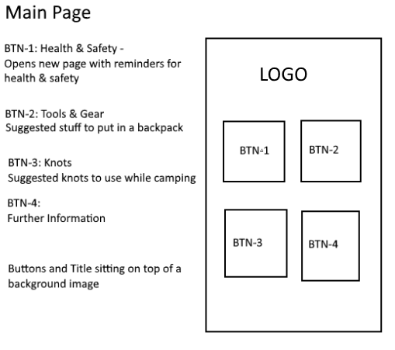

# Content Page2

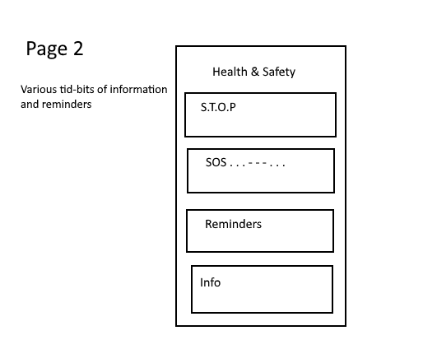

# Content Page3

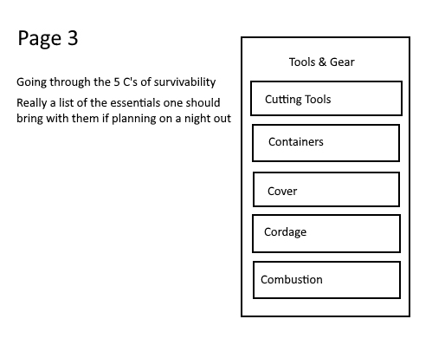

# Content Page4

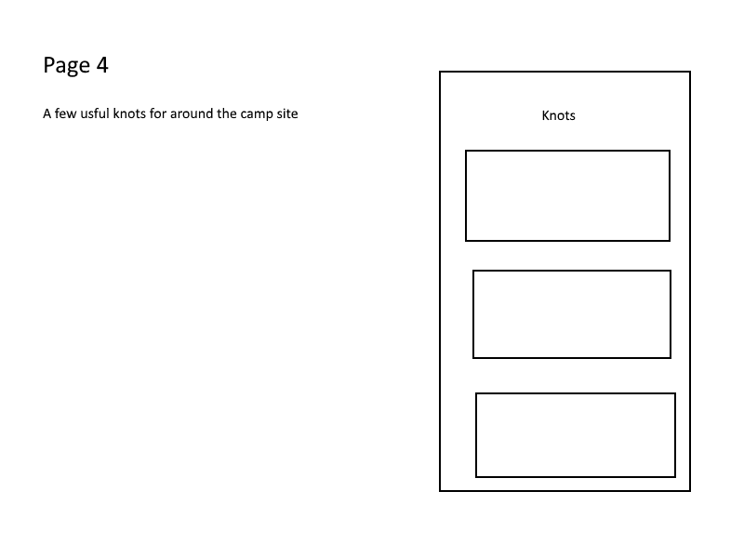

# Content Page5

